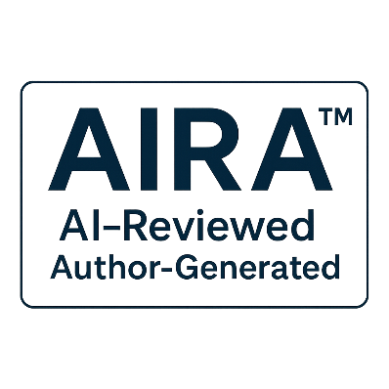
AIRA Annex A – Disclosure Templates v1.0
AI Reviewed, Author Generated A Transparency Standard for Human Generated Content

© 2025 B.L. Jensen
Licensed under Creative Commons Attribution 4.0 International (CC-BY 4.0)
tierverify-org is the steward and maintainer of the AIRA Standard.

Table of Contents
A.1 Introduction 2
A.2 General Text Content 2
A.2.1 Standard Disclosure 2
A.2.2 Alternative Form (Plain Language) 2
A.2.3 Minimal Form (Space-constrained) 2
A.3 Code and Technical Workflows 2
A.3.1 Commit Message Disclosure 2
A.3.2 Pull Request Disclosure 2
A.3.3 Inline Comment Disclosure 2
A.4 Audiovisual and Multimedia Content 3
A.4.1 Caption or Description 3
A.4.2 Transcript or Subtitle Note 3
A.4.3 On-screen or End-screen (Space-limited) 3
A.5 Multi-Author and Collaborative Workflows 3
A.5.1 Group Disclosure 3
A.5.2 Editorial Workflow 3
A.5.3 Organizational Output 3
A.6 Platform-Generated or System-Integrated Assistance 3
A.6.1 Embedded Tooling 3
A.6.2 Automated Formatting or Cleanup 3
A.6.3 System-Level Disclosure 4
A.7 Placement Guidance 4
A.8 Adaptation and Customization 4
A.9 Summary 4

A.1 Introduction
This annex provides standardized disclosure templates for indicating non-material AI assistance in human-generated content. These templates are informative and may be adapted for specific platforms, workflows, or organizational requirements, provided the meaning remains consistent with the AIRA Standard.

A.2 General Text Content

A.2.1 Standard Disclosure
“This content was reviewed with non-material assistance from AI.”

A.2.2 Alternative Form (Plain Language)
“AI provided non-material assistance during the review of this content.”

A.2.3 Minimal Form (Space-constrained)
“AI-assisted (non-material).”

A.3 Code and Technical Workflows

A.3.1 Commit Message Disclosure
“This commit includes non-material AI assistance (review, refinement, or clarification only).”

A.3.2 Pull Request Disclosure
“This pull request was reviewed with non-material AI assistance.”

A.3.3 Inline Comment Disclosure
“AI provided non-material assistance in drafting this comment.”

A.4 Audiovisual and Multimedia Content

A.4.1 Caption or Description
“This content includes non-material AI assistance for clarity or formatting.”

A.4.2 Transcript or Subtitle Note
“Transcript reviewed with non-material AI assistance.”

A.4.3 On-screen or End-screen (Space-limited)
“AI-assisted review (non-material).”

A.5 Multi-Author and Collaborative Workflows

A.5.1 Group Disclosure
“This work includes non-material AI assistance used by one or more contributors.”

A.5.2 Editorial Workflow
“Editorial review included non-material AI assistance for clarity and structure.”

A.5.3 Organizational Output
“This document incorporates non-material AI assistance consistent with organizational transparency practices.”

A.6 Platform-Generated or System-Integrated Assistance

A.6.1 Embedded Tooling
“This content was created using tools that may include non-material AI assistance.”

A.6.2 Automated Formatting or Cleanup
“Formatting and refinement include non-material AI assistance.”

A.6.3 System-Level Disclosure
“AI assistance was used for non-material review within this platform.”

A.7 Placement Guidance
Disclosures should be placed where they are visible to the intended audience. Recommended locations include:
- Document footer
- Preface or acknowledgments
- Commit messages or PR descriptions
- Video descriptions or end-screens
- Caption metadata
- Platform-specific disclosure fields
Placement must not obscure or misrepresent the nature of the assistance.

A.8 Adaptation and Customization
Organizations may adapt these templates to meet internal policies or regulatory requirements provided:
- The meaning remains consistent
- The disclosure clearly indicates non-material AI assistance
- The human author remains the primary creator
Custom templates should not imply material AI authorship.

A.9 Summary
Annex A provides standardized, flexible templates for disclosing non-material AI assistance across text, code, audiovisual, and collaborative workflows. These templates support consistent, transparent communication aligned with the AIRA Standard.

